 | REQUEST FOR ATTESTATION  FOR SEA SERVICE
 | Europe Head Office  5, Sachtouri Street  Piraeus, Greece,  18536, 6th floor  T: +30 210 4293500  F: +30 210 4293505 | USA Head Office  The Woodlands, TX, 77380 9595 Six Pines Drive,  Suite 8210  T: +1 832 631 6061  F: +1 832 631 6001

part 1. SEAFARER DETAILS
Name of Seafarer:
Name of Ship:
IMO Number:
Company:

part 2. supporting documents required
Please, provide us the following documents/information, declaring same is valid, correct and true.

Supporting Documents Required: | Attached |  | Official Use
Ship’s Articles: |  | ☐ | ☐
Copy of the seafarer’s Identification Record Book |  | ☐ | ☐
Official letter by the Company of the ship on board which the sea service has taken place |  | ☐ | ☐

part 4. declaration
I hereby declare that all information contained in all parts of this application is true, correct and valid. I am aware that in case of false information and/or documentation are found invalid or fraudulent or not authentic, the application process and/or the attestation will be cancelled immediately.
I also hereby acknowledge and affirm that I have reviewed and agreed with PISR GDPR Policy.
Name:
Signature: |  | Date:

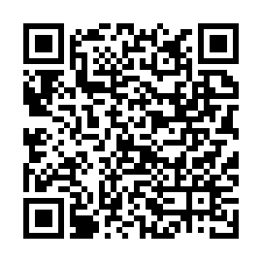
Scan to download this
application form

